Final Report

Somali Goal Tracker

Support to the Voluntary National Review of the Sustainable Development Goals in Somalia through a Somali Goal Tracker

July 8th 2022

Alexandra Silfverstolpe
Project Title: Support to the Voluntary National Review of the Sustainable Development Goals in Somalia through a Somali Goal Tracker

To the Somali National Bureau of Statistics (SNBS) and the
United Nations Development Programme (UNDP)

Report: Final Report Somali Goal Tracker

This report describes the services conducted during May and June 2022 by the Individual Contractor Alexandra Silfverstolpe in response to the Contract and Terms of Reference for Support to the Voluntary National Review of the Sustainable Development Goals in Somalia through a Somali Goal Tracker at the request of SNBS.

Background

The overall objective of this project is to enable Somalia to track progress against the Sustainable Development Goals (SDGs), by creating an online, user-friendly, open-access portal, based on the Goal Tracker platform. The Somalia Goal Tracker will offer a common platform to identify gaps and opportunities in the implementation of the SDGs, and could thereby increase the impact of all actors’ actions to meet the goals and targets. Besides contributing to the process of compiling the VNR, the Goal Tracker will also increase transparency and accountability for all actors engaged in the 2030 Agenda in Somalia, and thereby add value and greater ownership to the overall operationalisation of the agenda.

According to the contract the following deliverables were expected:

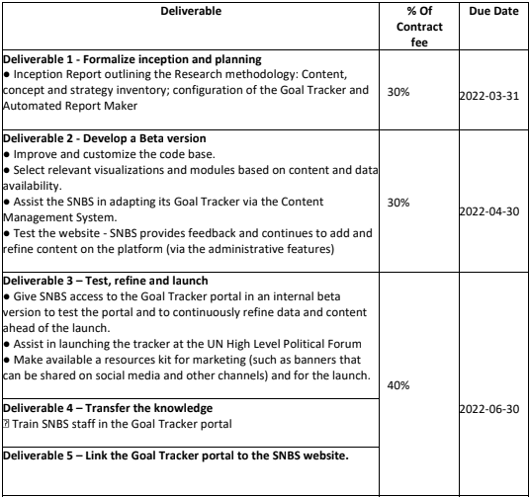

On May 11 2022, the consultant submitted a report for Deliverable 2 “Develop a Beta Version”. This report is focusing on deliverable 3 “Test, Refine and Launch”, deliverable 4 “Transfer the knowledge”, and deliverable 5 “Link the Goal Tracker to the SNBS website”.

Report activities May and June 2022

Deliverable 3: Testing, refine and launch (May - June)

During April and beginning of May the Somali Goal Tracker platform was created and configured. Development versions of a beta version of the Somali Goal Tracker portal were presented during several meetings in April and a beta version was officially shared with SNBS via email on the 8th of May.

As a lot of the data could not be disaggregated, manual work was carried out during April in order to visualize the data in the most suitable way. In May it was decided to do an overhaul of the code base of the data explorer so that the visualizations would be automatically updated when SNBS adds new data to the Somalia Goal Tracker data template. Extensive time was spent on updating the code base.

In parallel, during the whole month of May and June the portal was tested and all data, metadata and content was quality assured. Continuous refinement was carried out on a weekly basis. SNBS provided feedback on issues identified in the data by the Consultant and adjustments were made to the data and metadata. SNBS continued in parallel to refine the content on the platform and uploaded the VNR to the CMS.

Development of Automated Report Maker (May - June)

Initially the idea was to build an internal editing view on the platform that could automatically generate an outline for a report (for example a VNR). As a first draft of the VNR was not expected until mid-June an alternative route was taken to allow users download images from the data explorer for use in any kind of report (not being restricted to the VNR). The advantage of this approach is that from now on any user can download images from the platform and use it for multiple purposes (reports, presentations, social media etc) without being restricted by a predefined report outline. An export function was developed and a “download button” was created on the platform. By clicking the download button all visualizations in the data explorer can now be downloaded to the computer and be used for various reporting purposes.

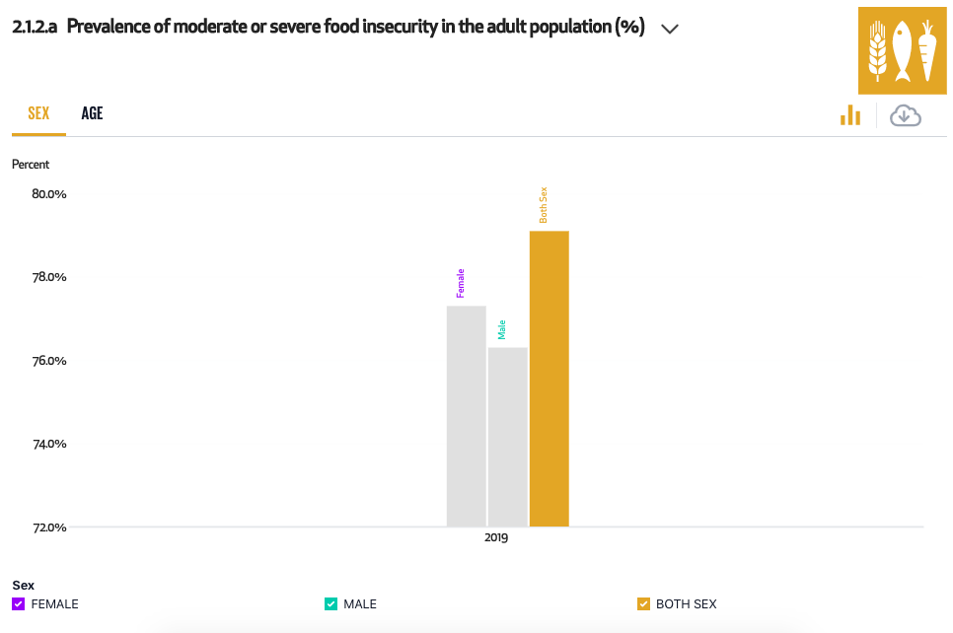
Download function

The Consultant downloaded a set of 20 images for SNBS to use for the upcoming VNR.

Preparation for launch (May)

As part of the Somali Goal Tracker functionality, a kit of resources was made available for marketing purposes including a set of banners, logos, gifs and a short screen recording of the platform that can be shared in social media and other channels. All marketing material is all accessible in this dropbox folder.

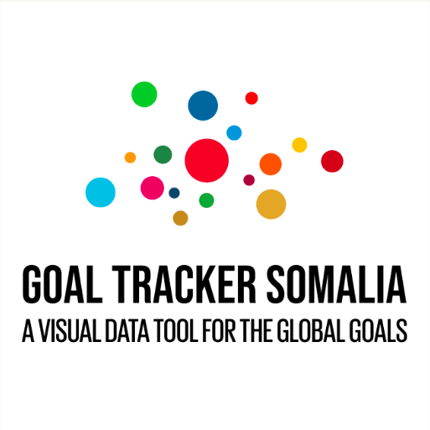
Logos, banners

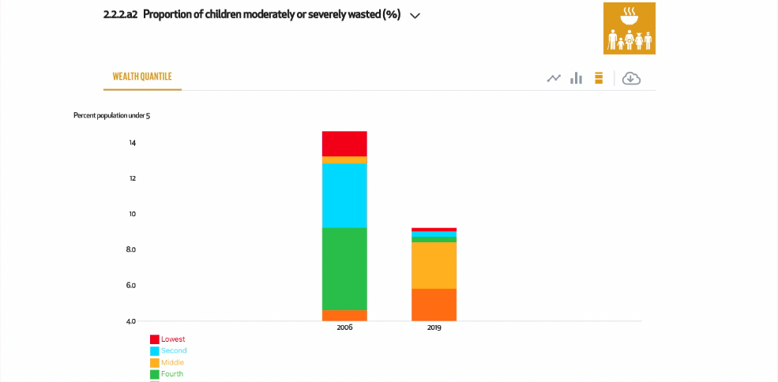

Gifs

Deliverable 4: Transfer the knowledge

Training of SNBS on data workflows and portal updates (June)

Written user guidelines on how to update the Goal Tracker with new data and content was developed during May and June. A user guide for the content management system was developed and shared with SNBS in May. In addition training sessions on how to update the CMS took place with the SNBS team.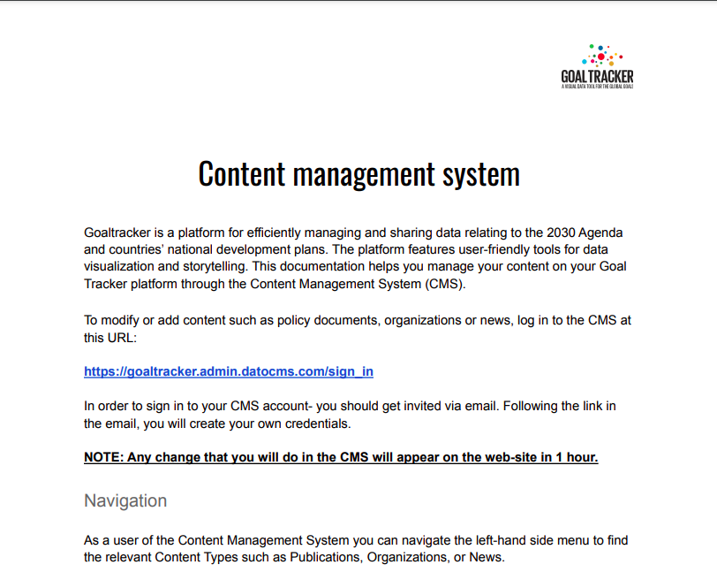

Documentation Content Management System

In June a Guide on how to update data and metadata to the template was developed and shared with SNBS. Also the Somalia Data Template which contains all data to drive the platform was shared with SNBS. A set of videos was also developed and shared with SNBS that:

i) explains the functionality of the data template,
ii) how to update metadata to the platform as well as
iii) adding new indicators and values to the platform.

This documentation will help SNBS to update and upload all data on the Goal Tracker platform through the excel template. The platform consumes all its data from the template. A core group at SNBS has been given editor permissions to the template and can invite other people at SNBS if/when they wish to do so.

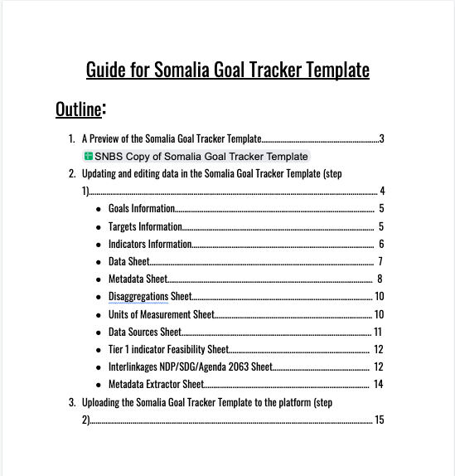
Guide for Somalia Goal Tracker Template

A training session with the SNBS team on how to update the platform took place on the 7th of July. The Consultant has offered to do one more additional training session with SNBS if needed (at no extra cost).

There are two main steps to upload/add new data to the platform:

1. Update data to the template. SNBS Copy of Somalia Goal Tracker Template
Suggested people within SNBS have been given access to the Somalia Goal Tracker Template.

2. Upload new data to the platform.
In order to make sure that the data has been inserted correctly in the template (and that it will not break the platform when uploaded), the Consultant has offered to assist SNBS with the upload of the new data to the platform throughout December 2022 (free of charge). The Consultant will then hand over the “upload” functionality to SNBS who will be fully responsible for uploading any new data to the platform beyond December 2022.

Beyond December 2022, if SNBS wants further support, an addendum to the current contract could be signed. SNBS could potentially choose from different service levels (from basic maintenance to having a dedicated project leader at hand to help with future updates and development of new features). The Consultant is happy to discuss this further with SNBS and UNDP.

Deliverable 5: Launch of the Somali Goal Tracker and inclusion of the SNBS website (30 June)

Goal Tracker Somalia has now been linked to a new domain name developed by SNBS. The platform is accessible on goaltracker.nbs.gov.so. The platform is also accessible via the goaltracker home page (goaltracker.org).

Goal Tracker Somalia was officially launched together with the VNR at a local event in Mogadishu on the 2nd of July. In addition to the marketing material the Consultant developed a powerpoint presentation together with speaking points for SNBS ahead of the launch. A presentation has also been developed by the Consultant for SNBS to use at the upcoming HLPF Side Event “Data Innovations for data driven VNRs” in New York which is expected to take place on the 14th of July (organized by the UN Statistical Division).

Summary

The project was completed successfully despite a very tight time frame. There were some delays in the development of the Beta version primarily as it turned out that the data that was provided by SNBS was not suitable for consumption of the Goal Tracker Platform. Hence thousands of rows of data had to be manually transferred by the Consultant to a suitable format.

Data for 84 indicators have now been included in the Somali Goal Tracker platform. As a lot of the data can not be disaggregated some manual work has been carried out in order for the data explorer to visualize the data in the most suitable way. A decision was made to make an overhaul of the code base in order to make sure that the visualizations in the data explorer can be updated in a correct way automatically when SNBS adds new data to the Somalia Goal Tracker data template in the future.

Initially the idea was to build an internal editing view on the platform that could automatically generate an outline for a report (for example a VNR). As a first draft of the VNR was not expected until the beginning of June it was agreed that an alternative solution to the “report maker” was preferred. An “export button” was developed and included in the data explorer which now allows any user to download any of the visualizations in the data explorer for future use in reports, PPT presentations and social media.

The Somalia Goal Tracker has now been launched at a big event in Mogadishu on the 2nd of July. The Somalia Goal Tracker will also be presented at the upcoming HLPF in New York on the 14th of July, which is a great and encouraging achievement.

It has been a true pleasure to work with SNBS and its dedicated and skillful team and consistent leadership throughout the project. We want to thank the SNBS team for all valuable efforts throughout the project and the UNDP for its generous support and commitment to advance the Agenda 2030 in Somalia.

